Lab 2: Privacy with Wireshark and TLS

Wireshark output after visiting unt.edu

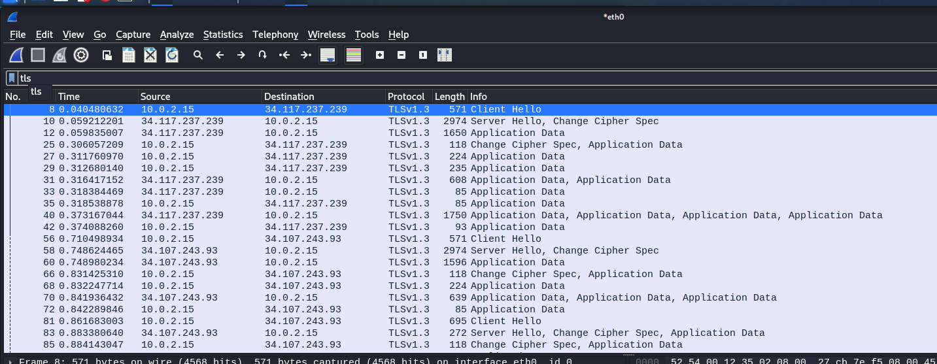

TLS handshake packet data for :

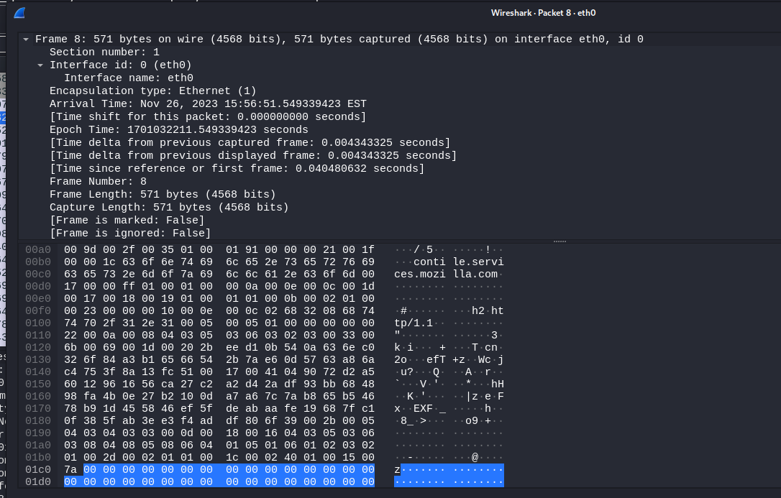

After completing the handshake, view of application data packet:

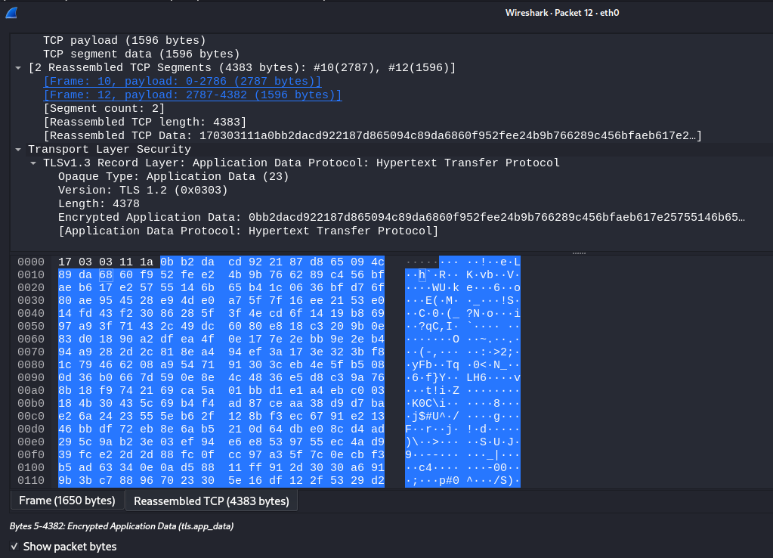

TLS stream:

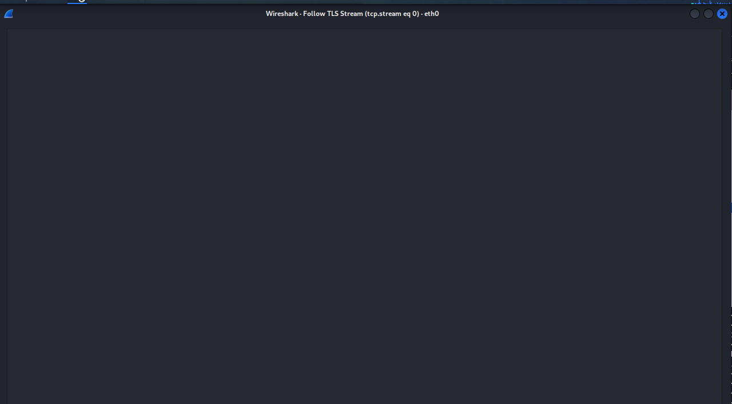

Note: The SSL protocol (SSLv2 and SSLv3) hasn't been in use for several years, having been superseded by TLSv1. While some programs still start with SSLv2-compatible handshakes or occasionally use the SSLv2-style record format, they all generally use **tls** nowadays and the Wireshark configuration page has been renamed accordingly. The display filter is tls.

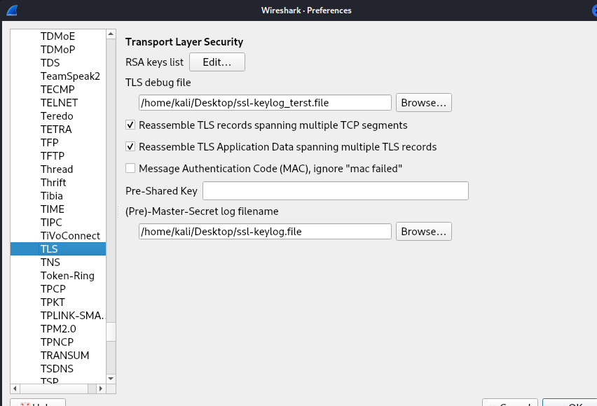

Decrypted TLS stream: As the ssl being

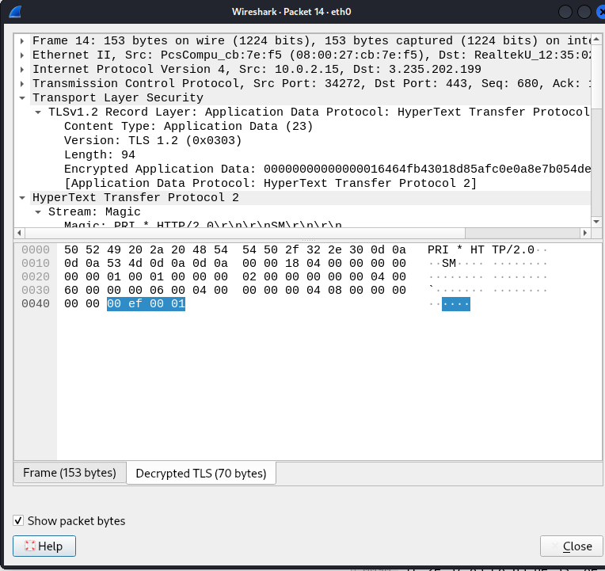

Other packet:

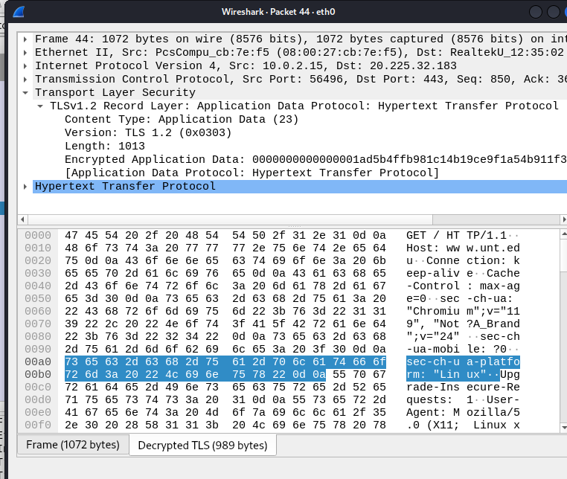

Now looking for the http packet:

